SG3 Group 6 User Manual

Anthony Burrows
Zach Brown
Khristian East
Diamon Daniels
CMP_SCI-4500
05/09/2025

Table of Contents
SG3 Group 6 User Manual 1
Introduction and Installation 3
Running the Program 4
Program Workflow 4
Locating Output Files 5

Introduction and Installation
This user manual is written for biologists with no programming experience. It describes in detail how to run the program, what the program does, and where to find the output files in the directory.
Prerequisite: You must have Python installed on your computer. To check that it’s installed:
- On windows/PC: open a terminal and type ‘python -version’
- On macOS: open a terminal and type ‘python3 --version’
- You should see the message ‘Python3.13.2’ or something similar on your screen
- If you don’t see the message, that means that Python is not installed or you have an older version. You can download and install the latest version of Python from: https://www.python.org/downloads/.
Verify Program Files:
Confirm in the compiled program directory that you have at least
- An ‘sg3.py’ file: this is the main program script
- and a valid csv file or a folder for different csv input test files.
  - Place whatever input csv files you have inside the data or file folder.

Running the Program
When all files and software have been created, installed and you have navigated to the correct directory on your open terminal, launch the program by typing:
- ‘python sg3.py’ for windows or
- ‘python3 sg3.py’ for a mac

Program Workflow
If everything is working correctly, you will get a screen message of the program introduction message and the program will:
- Prompt for a csv filename
- Check that the file entered has a .csv extension (not case sensitive)
- Verify that the file exists in the directory
  - If it doesn’t contain the .csv extension, it will repeat the last three steps above - see extra screenshot 1
- Process the verified file and generate one heatmap image and 4 output files:
  - Species.txt, DatedData.txt, PresentAbsent.txt, and HeatMap.txt
- Print reports of how many names and dates are in the file, max abundance of each species, multiple present/absent appearances, and the heat map will be reported on the screen as well.
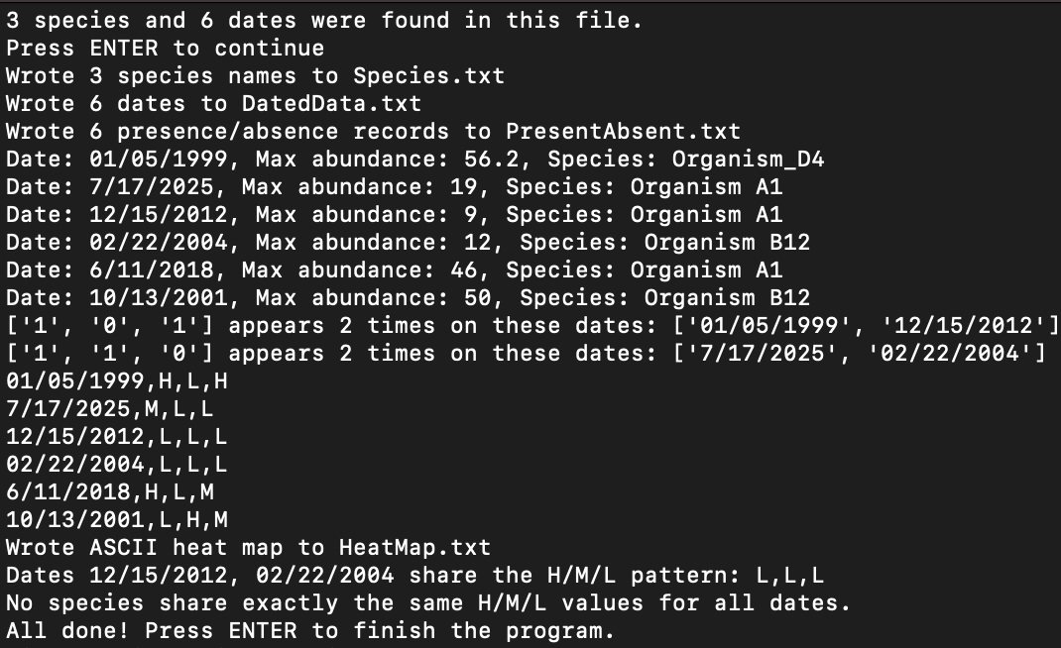
(sample screen display of a correctly processed csv file)

Locating Output Files
If you want to see the files created by the program, there are multiple ways of finding them.
- If your terminal is still open in the same directory as the program, type:
  - ‘ii .’ for windows
  - ‘open .’ for mac
- Or if you closed your terminal, open your terminal again, navigate to the directory the program is in using “cd \directory name\” in the terminal, then type:
  - ‘ii .’ for windows
  - ‘open .’ for mac
- Or you can open up file explorer and look through the directories and find the directory the program is in

Through any of these options, you should see file explorer open with the new output files. - see extra screenshots 2

Extra Screenshots
1.
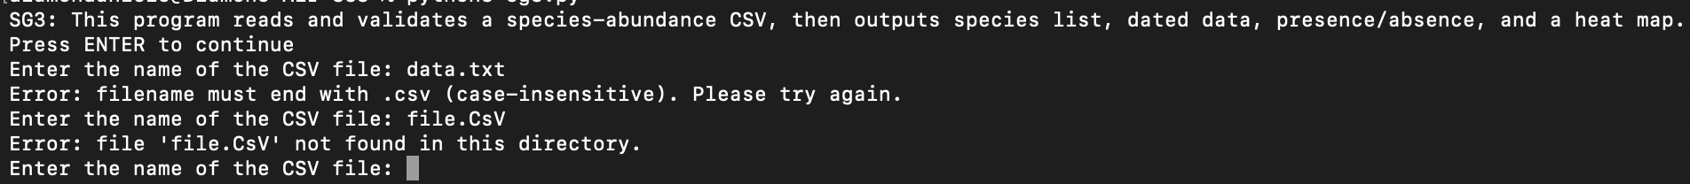
-the program keeps prompting for a file ending in .csv and is in the working directory

2.
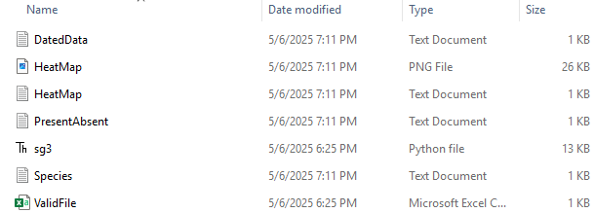
-example directory structure after running the program on a windows computer

